1、Enter bootloader to check boot version, the following is 1.1.3, See upgrade document for entering bootloader.

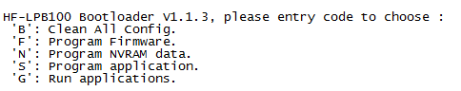

The following is 1.0.7 version

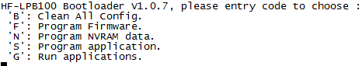

2、For 1.0.7 and below, add “1.0.07” directory target file. For 1.1.3 and above verstion, add “1.1.3” directory target file, the steps is as following

1. Copy MV18X_XXXX to Keil following directory

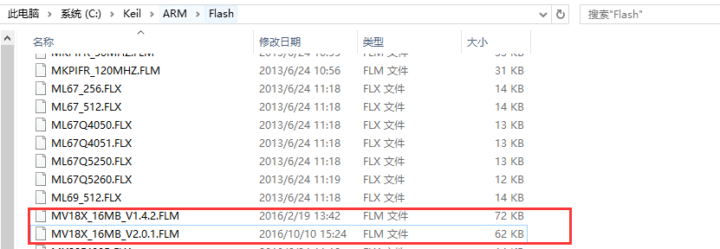

1. select MV18X for responding bootloader version. The following take 1.1.3 for example.

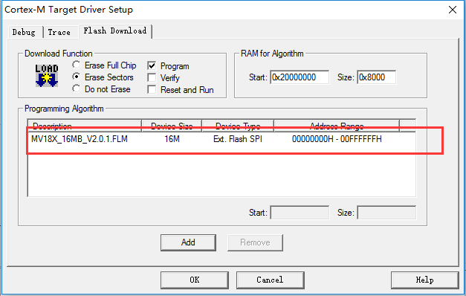

1. 根据boot版本选择对应的ausdk_download.ini文件。

